Project 2

(21)

Melvin Tran

Class: CSC-5 40717

Due: 02/12/2015

**Introduction**

Title: 21

The game 21 is played with a player and a dealer. The purpose of the game is to get 21 in order to win automatically. If that doesn’t occur then who ever has the largest number below 21 and higher than either player wins the game. But if the player bust, which his cards are greater than 21 the dealer you automatically win and vice versa.

This is the window that explains the game.

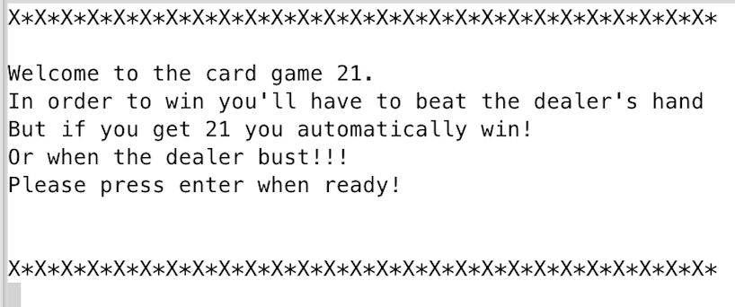

This is the menu of the game when started.

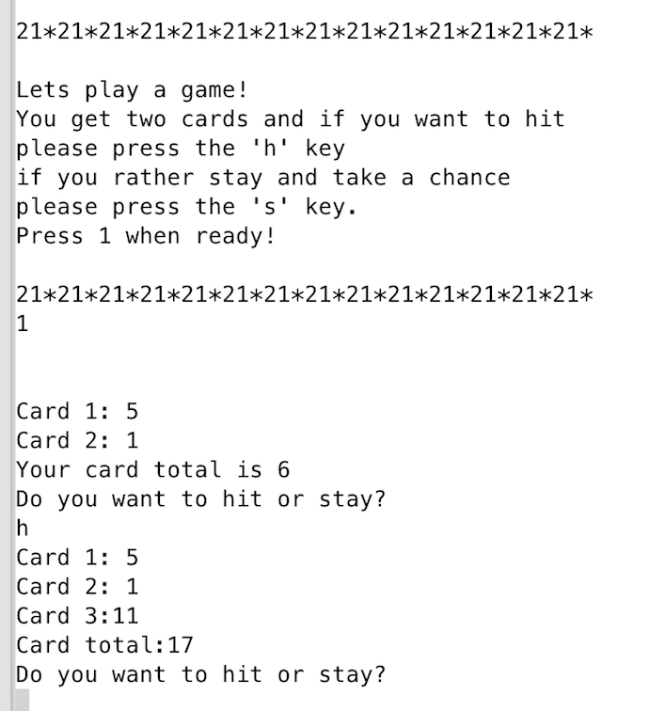

You have to press 1 in order for the game to start. If not it will exit the game. Example below.

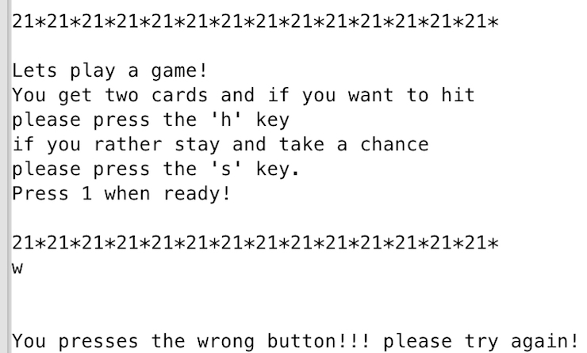

You start off with two cards that you combine to get the total. You get four chances (hit) to get as close to 21 but if you’re below that and don’t want to take a chance of busting then you can stay. Cards in the deck ranges from 1 to 11.

**Summary**

Project size: About 283 lines

The number of variables: 25

The number of method: 6

**Description**

The main point that I programmed this project is a button handler.

I programmed the action performed as what button is pressed.

**Flowchart**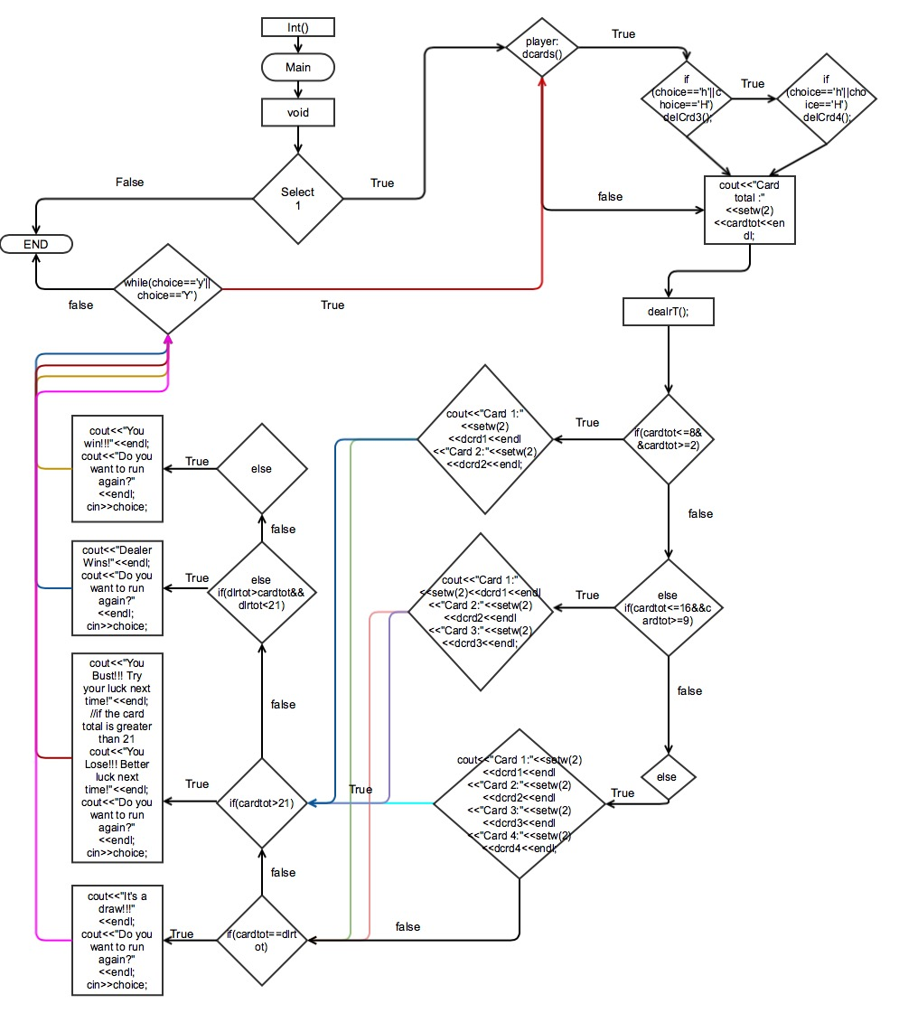

**Pseudo Code**

*Initialize*

*Press enter to start the menu*

*If 1 is pressed the game starts*

*Else if the game ends and prompt the user to try again*

*If user chose the correct key*

*The game will start with two cards*

*The user gets to choose to stay or hit*

*If user choose to stay*

*The dealer will start its turn*

*If else the player continue to hit*

*For four turns if he/she chose too*

*If dealer plays*

*The dealer will try to beat the player hands*

*If dealer bust or lose*

*The player wins*

*Prompt the user if he/she wants to play again*

*If else player bust or lose*

*The dealer wins*

*Prompt the user if he/she wants to play again*

*If player chose not to play*

*The game ends if user doesn’t want to play again*